Sample element

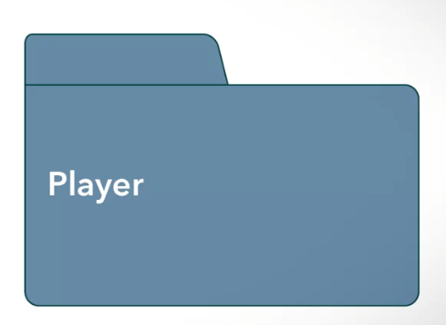

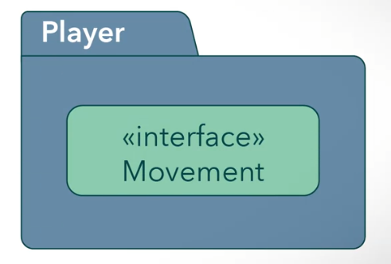

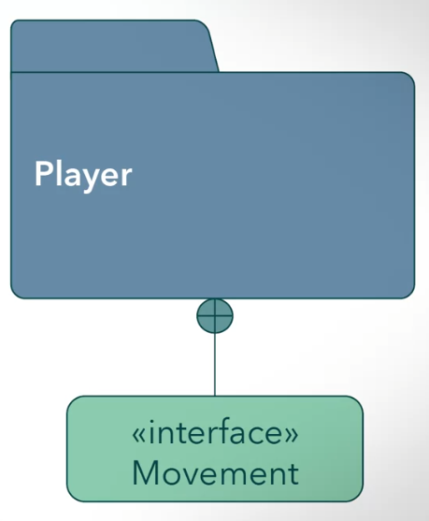

(composition)

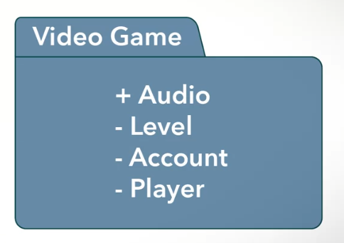

Relationship example

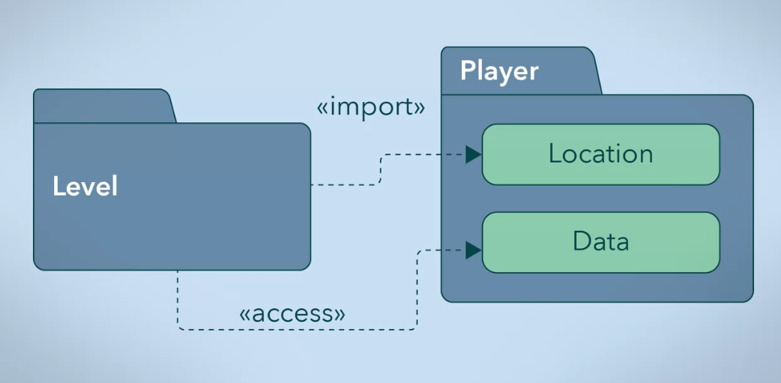

<<import>> - public

<<access>> - private

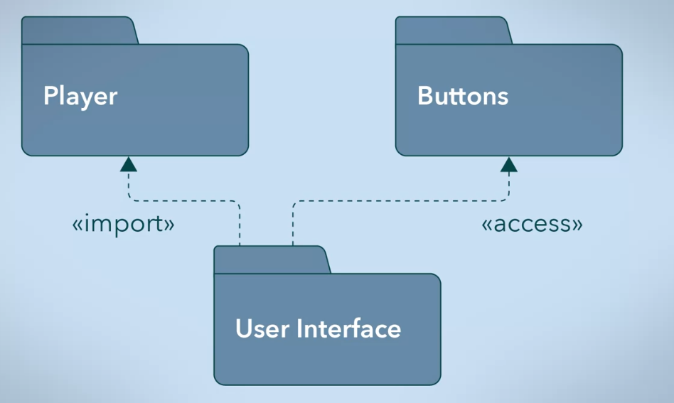

Merging

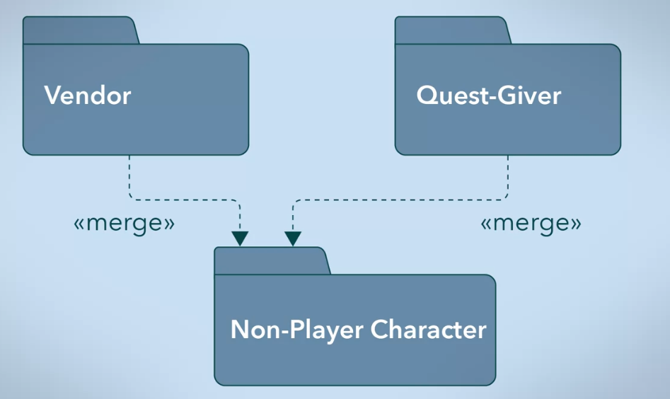

Sample video game package diagram

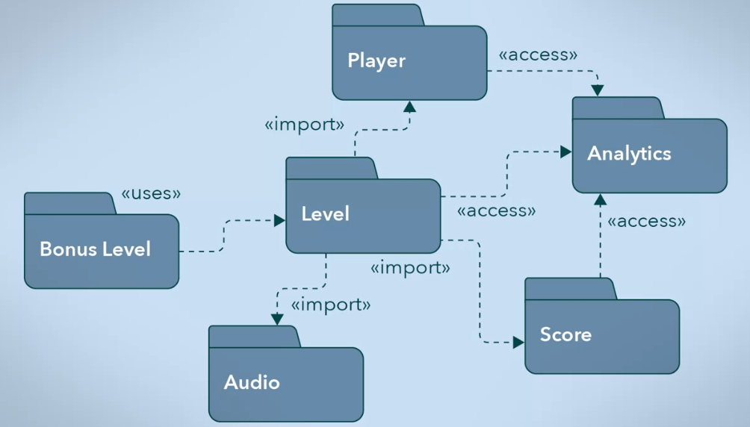

<<uses>> - requires the one that is using to be in FULL IMPLEMENTATION.

Eg. bonus level requires full implementation for level

* If there are no implementation for level, then there CAN’T be a definition for bonus level